
East West University
Department of Computer Science and Engineering

Course: CSE251 Electronic Circuits
Expt No.: 5
Title: Signal Integration and Differentiation Using 741 Op-Amp

Objectives:
- To study the responses of Op-Amp integrator to sinusoid and square waveforms.
- To study the responses of Op-Amp differentiator to sinusoid and triangular waveforms.

Introduction:
Operational Amplifier (Op-Amp) is a differential amplifier and can perform mathematical operations such as addition, subtraction, integration, differentiation, etc. In Expt. No. 3, we use the Op-Amp together with the only resistors to study adder and amplifier circuits. In this experiment, we will study integrator and differentiator circuits by using a capacitor either in the feedback path or in the input path.

Circuit Diagram:
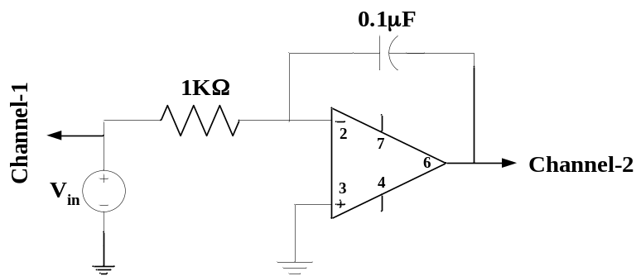
Figure 1. An Op-Amp integrator circuit.

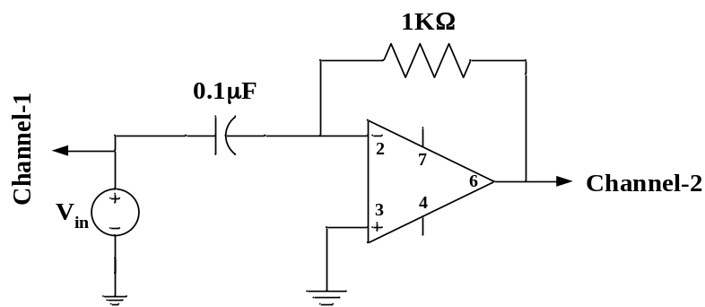
Figure 2. An Op-Amp differentiator circuit.

Equipments and Components Needed:
- Digital trainer board
- Signal generator
- Oscilloscope
- Digital multimeter
- 741 Op Amp (1 pc)
- Resistor (1KΩ 1 pc)
- Capacitor (0.1µF, 1 pc)
- Breadboard
- Connecting wires

Pre-Lab Report Question:
- INTEGRATOR: Consider the integrator shown in Figure 1 with 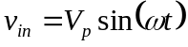. If the circuit is initially relaxed, find the expression of output and determine the frequency, f, at which the output amplitude is equal to 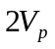. Also, determine the phase relation between input and output.
- DIFFERENTIATOR: Consider the differentiator shown in Figure 2 with . If the circuit is initially relaxed, find the expression of output and determine the frequency, f, at which the output amplitude is equal to 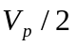. Also, determine the phase relation between input and output.

Lab Procedure:
INTEGRATOR:
- Measure the resistance and write it down. Connect the circuit as shown in Figure 1. Use a +5V DC power supply to terminal 7 and -5V DC power supply to terminal 4 of the Op-Amp. Use fixed 5V and -5V DC supply of digital trainer board or 0 to15V and 0 to -15V DC variable power supply from the digital trainer board.
- Use a 2V peak to peak sine wave V_{in} from the signal generator. Set the sine wave frequency to the one that you have determined in your prelab design.
- Observe the output in channel-2 and input in channel-1 using dual mode. Write the amplitudes of the input and output signals and the phase difference between them.
- Change the input from sine wave to square wave (do not change the frequency and magnitude) and observe the output in dual mode. Draw both the input and output wave forms with voltage and time axes labels.

DIFFERENTIATOR:
- Connect the circuit as shown in Figure 2. Use a +5V DC power supply to terminal 7 and -5V DC power supply to terminal 4 of the Op-Amp.
- Use a 2V peak to peak sine wave V_{in} from the signal generator with frequency from you prelab.
- Observe the output in channel-2 and input in channel-1 using dual mode. Write the amplitudes of the input and output signals and the phase difference between them.
- Change the input from sine wave to triangular wave (do not change the frequency and magnitude) and observe the output in dual mode. Draw them with voltage and time axes labels.

- Have the datasheet signed by your instructor.

Post-Lab Report Questions:
INTEGRATOR:
- In the output expression from your prelab, put the measured value of R and the given values of C and V_{p}; calculate the amplitude of the output signal and compared it with the measured data.
- Compare the phase relation between your prelab result and measured data.
- Simulate the integrator of Figure 1 for 4 cycles using PSpice with the measured value of R and the square wave input that you have used in the lab and have the simulation result printed. Compare the simulation result with your measurement.

DIFFERENTIATOR:
- In the output expression from your prelab, put the measured value of R and the given values of C and V_{p}; calculate the amplitude of output signal and compared it with your measured data.
- Compare the phase relation between your prelab result and measured data.
- Simulate the differentiator of Figure 2 for 4 cycles using PSpice with the measured value of R and the triangular wave input that you have used in the lab and have the simulation result printed. Compare the simulation result with your measurement.

